About Me

This page is all [about me](http://amazon.com/author/debbienicholson) – Debbie Nicholson.

[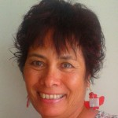](http://www.amazon.com/Debbie-Nicholson/e/B008Q4WNDE)

Hi there

My name is Debbie Nicholson and I am an author on Amazon in the Kindle Store as well as privately here on my own websites. The Internet opens up a whole new world to us if we want it to and I am excited to be part of this online experience.  
[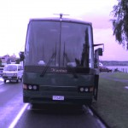](http://debzbim.com/)

I work from home which is a mobile home and currently we are parked in a holiday park very close to the beach down under here in New Zealand.  
[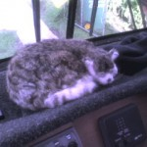](http://debzbim.com/)

This is our cat who is very low maintenance and has a great story behind him.  His name is Mr Chippy.

[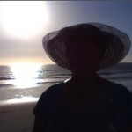](http://debzbim.com/)

This is the lifestyle we are able to live with the help of online income.

[](http://debzbim.com/)

This is my darling husband Keith who still likes to work on call when someone calls him in to relieve workers when they want time off.

We have 3 children and 3 inlaw children. We have 9 grandchildren, and 3 Great Grandchildren.

I am a member of [The Church Of Jesus Christ Of Latter Day Saints](http://www.lds.org/?lang=eng)and this is a picture of our Temple in Hamilton where I like to spend 2 weeks of my time once a year for spiritual upliftment.

[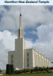](http://en.wikipedia.org/wiki/Hamilton_New_Zealand_Temple)

If you would like to know more [about me](http://amazon.com/author/debbienicholson)then I encourage you to click on the links provided.

Kind regards

Debbie

Hyperlink

<https://www.amazon.com/Debbie-Nicholson/e/B008Q4WNDE>

Hyperlink

<https://www.lds.org/?lang=eng>