As we live in a mobile home we are constantly on the move for a few weeks at a time and we may settle somewhere for a few days, weeks or months depending on the activities we can engage in within the community or local area or just to rest somewhere.

Therefore all of our mail gets directed to our Post Box and every week we have it couriered to where we are at the moment.

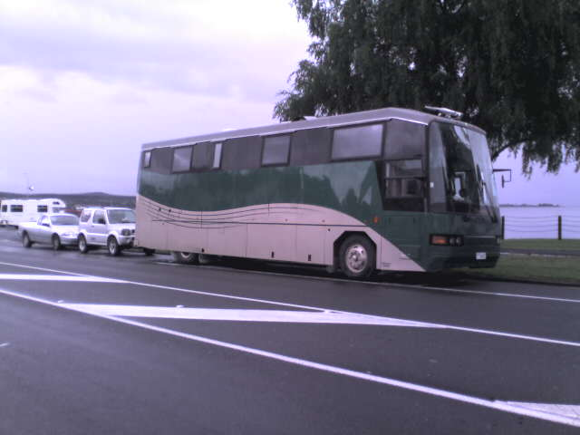

For further information please contact:  
Debbie Nicholson   
P O Box 54030  
Mana  
Porirua 5247  
New Zealand

Ph +64 22 103 1123

Skype : skypedebbien

stories4debbie@gmail.com